

14 July 2022

**Terra Industrial New Zealand Ltd**

PO Box 16 168

16 Branston Street, Hornby

Christchurch 8441, New Zealand

03 983 2333 Tel

www.TerraCat.co.nz

**Import and Export label files**

Label are pretty different in AX2012 instead of earlier version of AX. Here is quick steps to import and export Label files from one Environment to other. You also perform an update on label files.

**Export a Label file:**

Open AOT, Expend Label node. Choose Label and require language to export. You can do it for individual language or you can select multiple language all in once.

[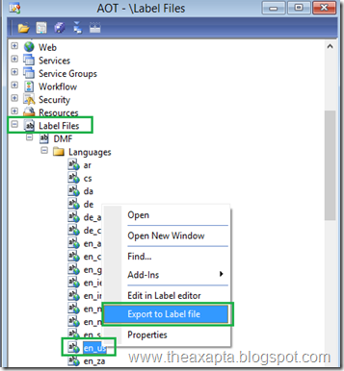](http://lh3.googleusercontent.com/-4p6K70paMM0/VfUoM7339_I/AAAAAAAABDE/YaEA9aJfXhs/s1600-h/image%25255B27%25255D.png)

Exported file will save on selected path with extension “.ald”.

**Import Label File:**

Right click on Label node in AOT and select “Create from File”, choose ald file to import than hit create.

[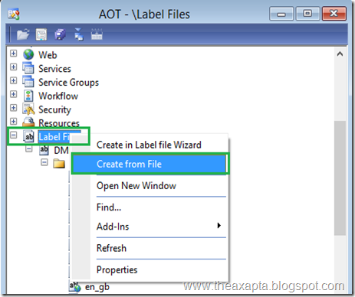](http://lh3.googleusercontent.com/-c09O9QGoB2M/VfUoOAX-oTI/AAAAAAAABDU/2h9FuygHuMs/s1600-h/image%25255B25%25255D.png)

[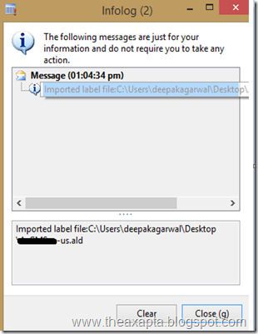](http://lh3.googleusercontent.com/-Esq2zdY7VCQ/VfUoPRy3h9I/AAAAAAAABDk/T7X2pylmZU8/s1600-h/image%25255B23%25255D.png)

**Update a Label file:**

Import the new updated label file system will ask to overwrite , go ahead

[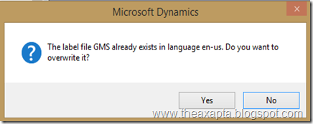](http://lh3.googleusercontent.com/-iMk46L0Bwi8/VfUoQu5OmhI/AAAAAAAABD0/dC5zwx8-4QA/s1600-h/image%25255B21%25255D.png)

It will update your existing Label file.

Note: You must run full Synch after every import/Update.

More info: <https://technet.microsoft.com/en-us/library/gg731886.aspx>